**ECE9407– PSoC 4 BLE Lab #3**

**IoT Sensor Based System Design**

**Name: An He, Amr Gaballab**

**Number: 250847871, 250776065**

**Data: 2016-06-17**

**Instructor: Dr. Ahmed Hussein**

**LAB 3 REPORT**

# **1.Introduction:**

This lab aims to create a heart sensor device that measures an analog signal (heart beat rate) as an input to the device and transform it to a digital electric signal that can be measured through devices such IPhone. BLE Heart Rate profile defines how the user’s heart rate information is communicated from one device to another. This is used in health and fitness applications in modern wearable devices

The two BLE roles defined by find me profile are:

1. Heart Rate Collector (GATT Client): Receives the heart rate information. It is implemented in mobile phones and tablets.
2. Heart Rate Sensor (GATT Server): Detects the heart rate and stores information. It is implemented in fitness bands and activity monitors.

To generate heart rate, PSOC 5 is applied to the test board. The signal is detected by using an Operational Amplifier (OpAmp) as an input buffer and then passing the signal to the ADC. The detected signal is compared to a threshold and whenever a beat is detected, its time of occurrence is noted. The time difference between successive beats is extrapolated to 60 seconds to get a corresponding heart rate value.

The following graph demonstrates the block diagram of the system:

The BLE Pioneer Kit will act as the Find Me Target:

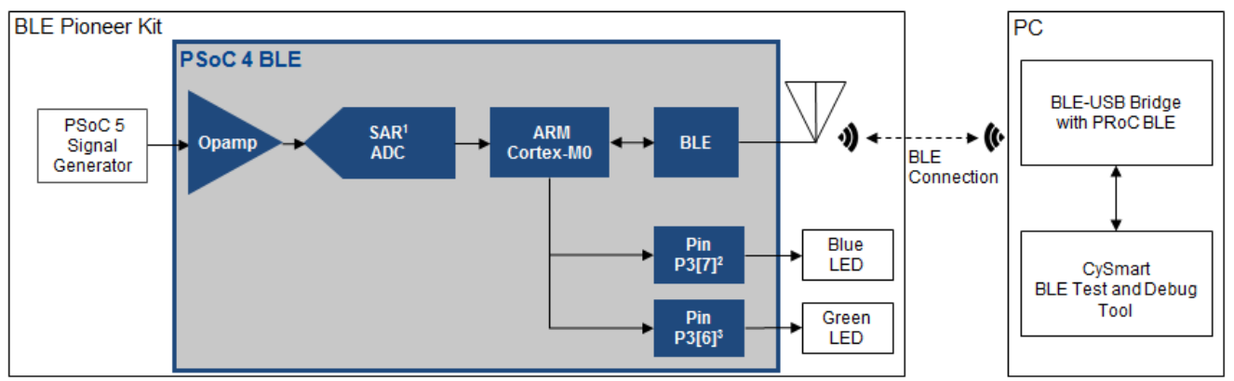

# **2.Procedure:**

1. Open the template project BLE LAB 3: 

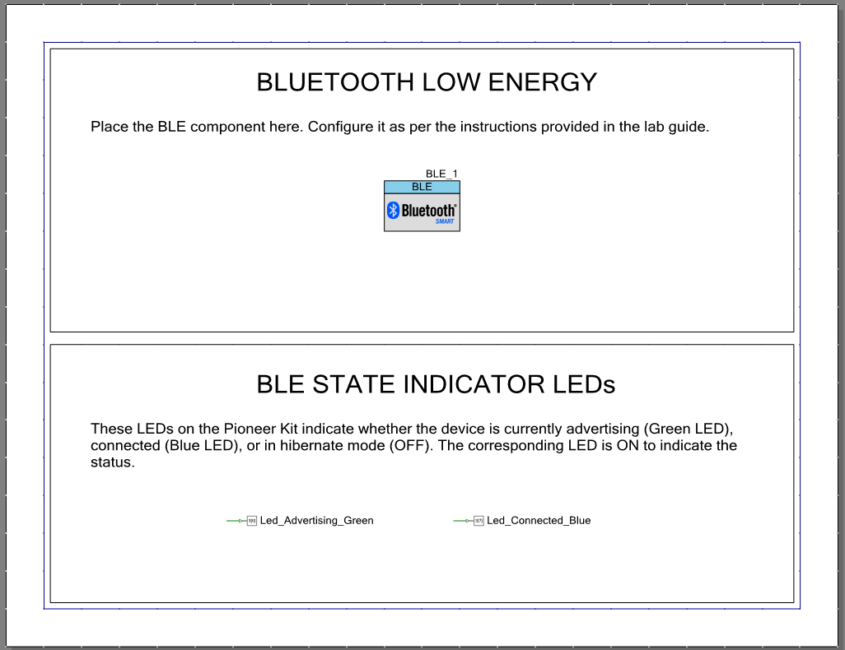

1. Click on the BLE component to open the configuration. Change the profile to Heart Rate, and make the role Heart Rate Sensor. This is shown in the figure below:

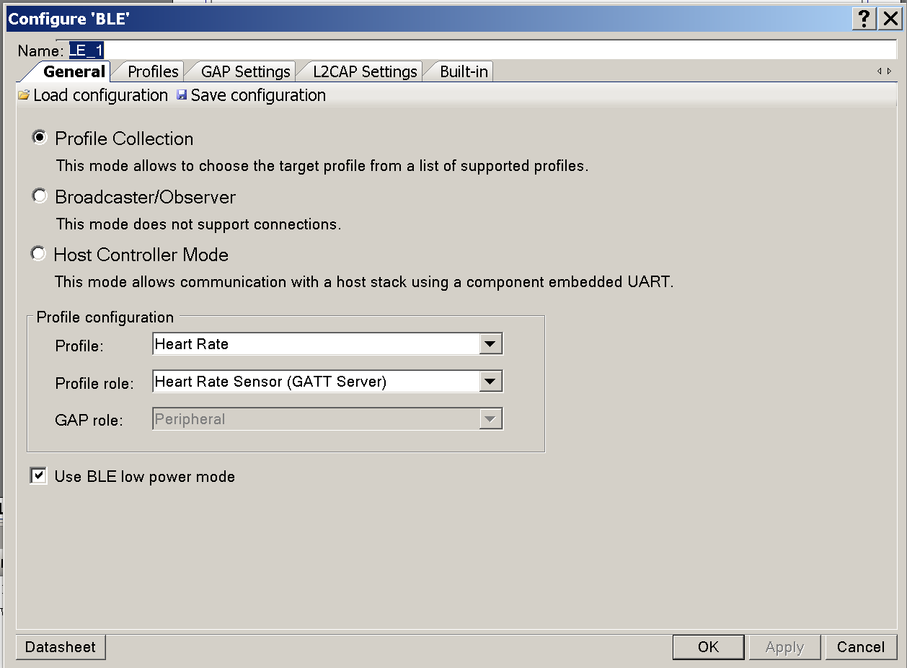

1. No changes are done in the profile tab as below:

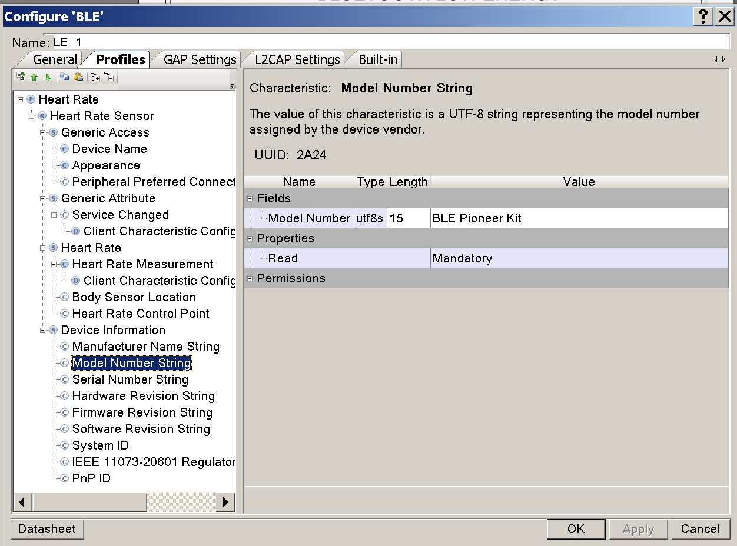

1. Click on the GAP settings, and change the device name and appearance as below:

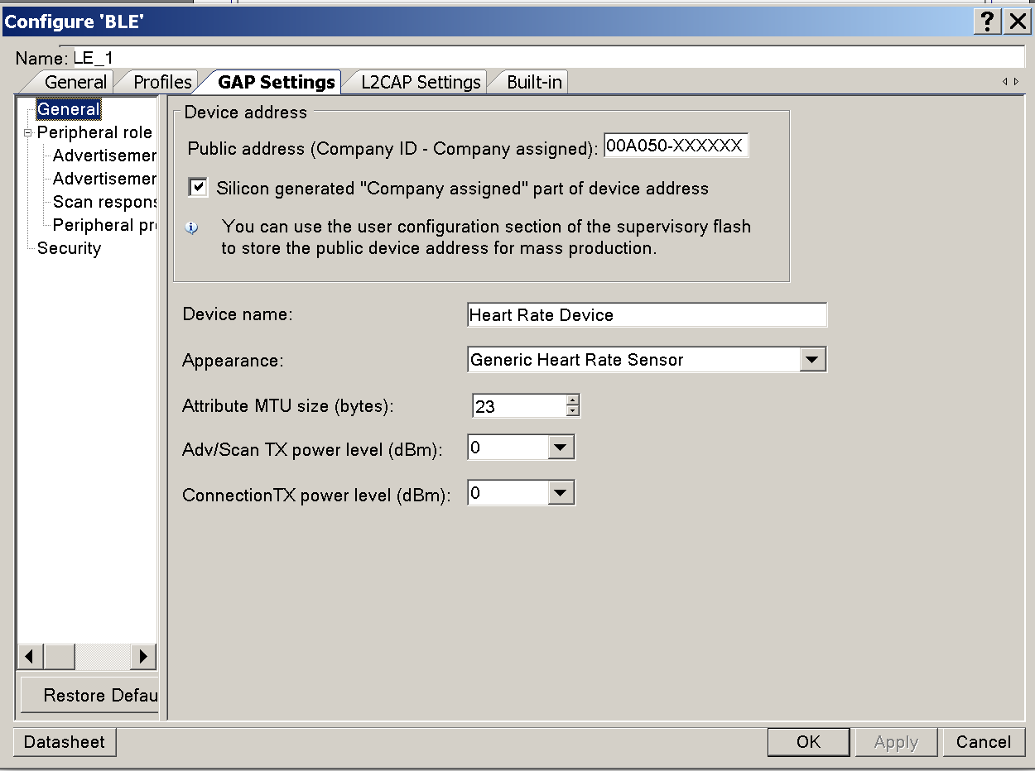

1. From the left click on advertisement settings then change the settings as below:

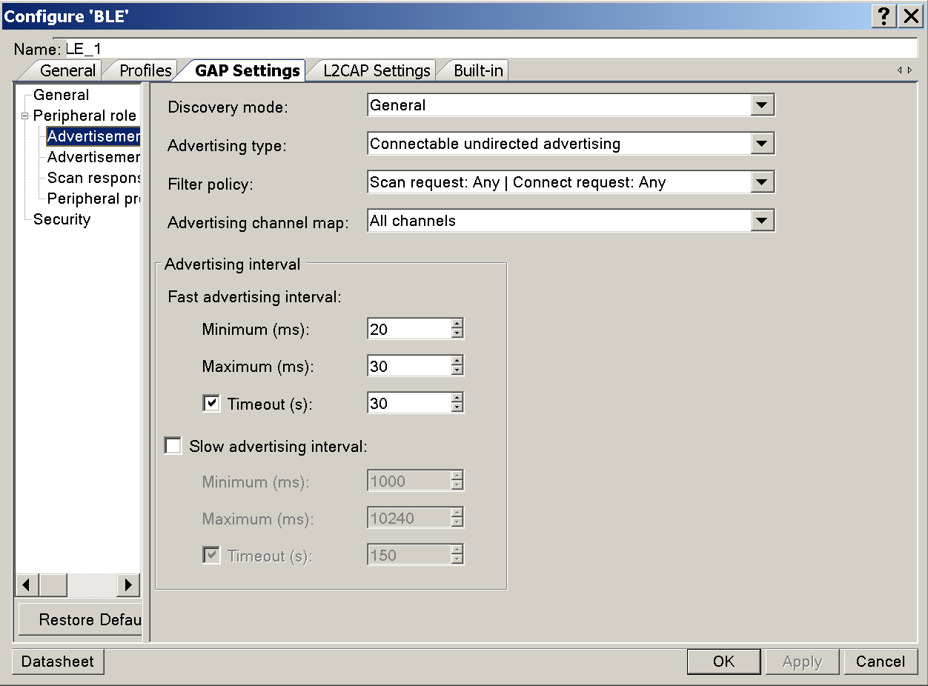

1. Click on Advertisement Packet from the left then apply the changes below:

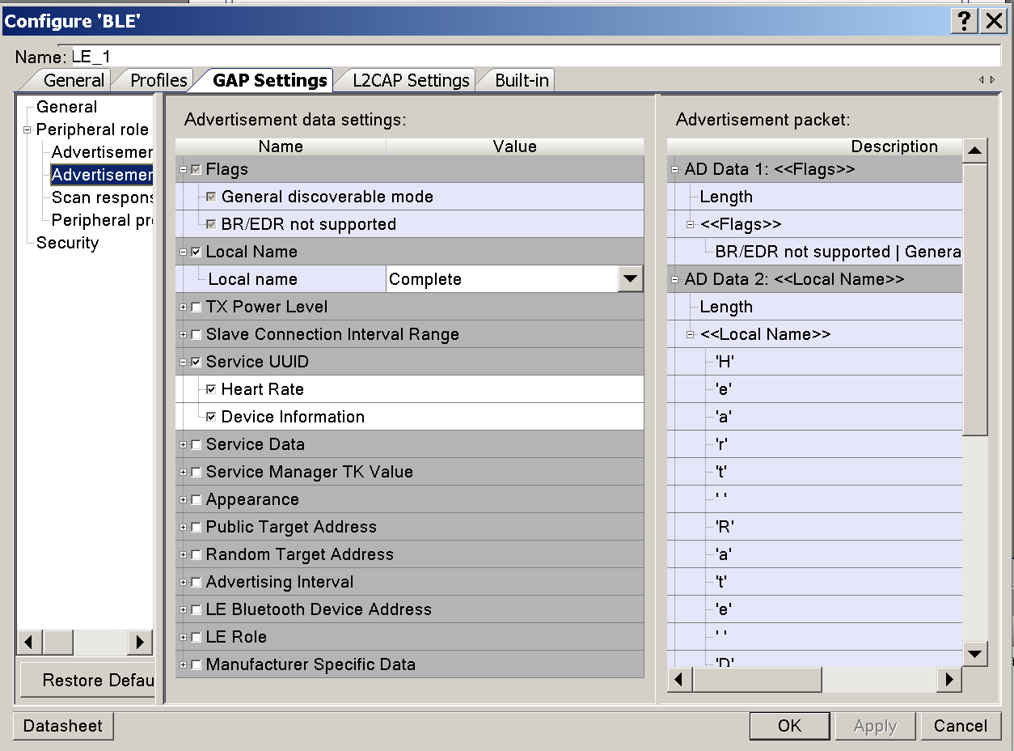

1. Change the properties of the scan response as below:

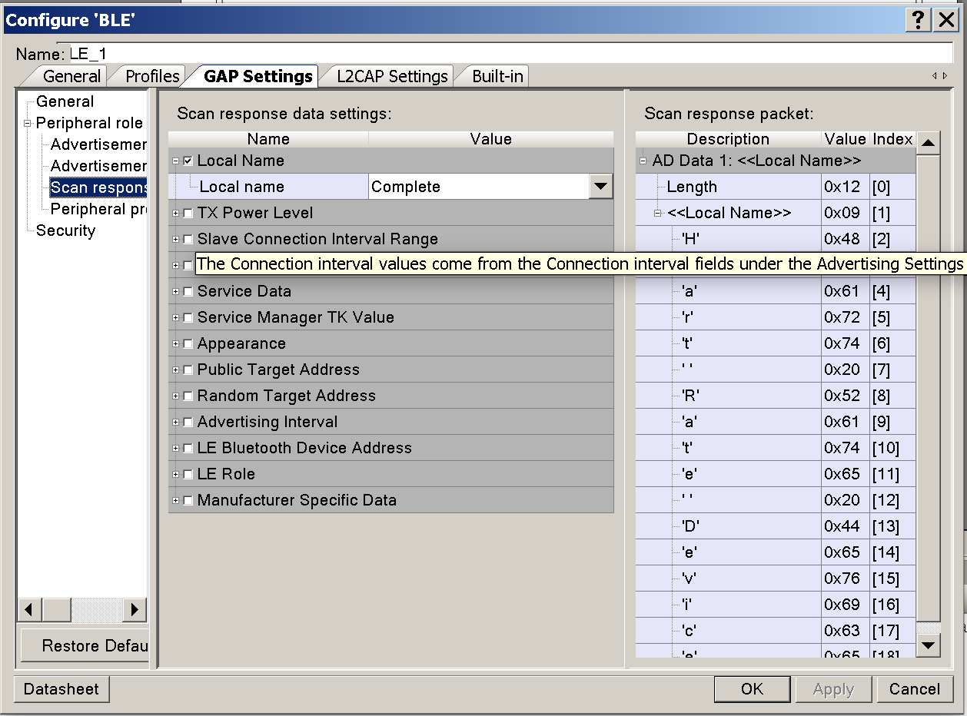

1. Change the security settings as below, then click ok to save and close the configuration settings.

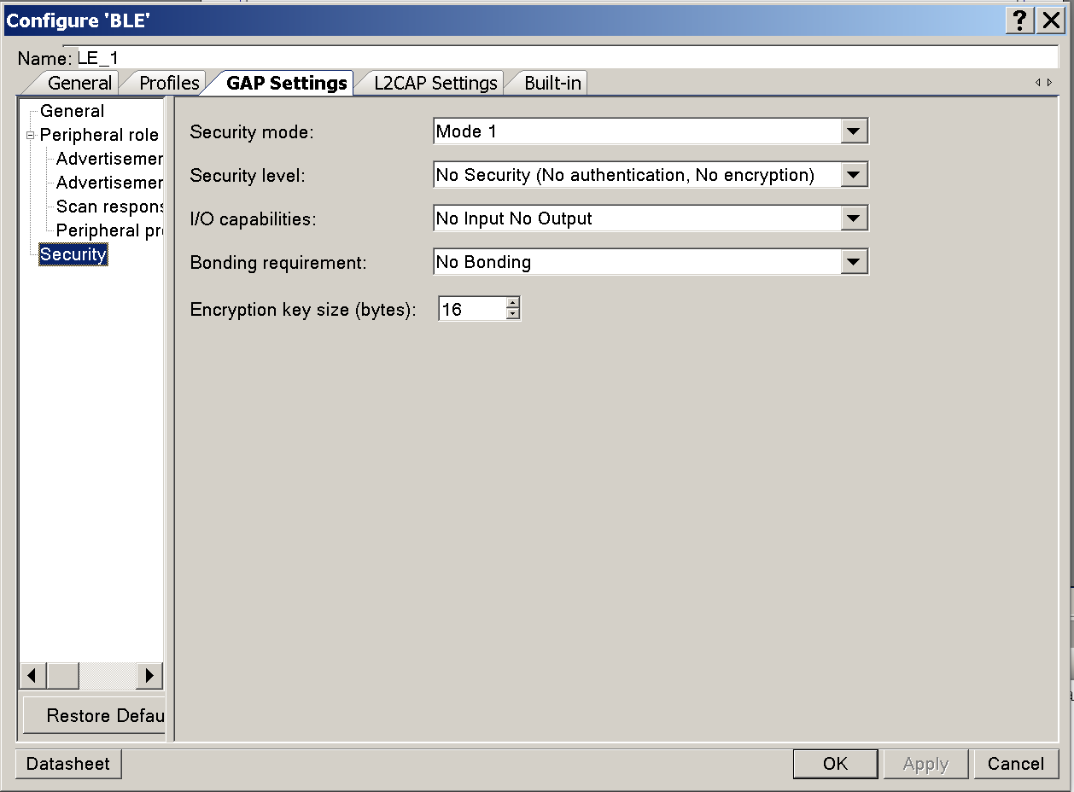

1. Click on Analog front end to configure the OpAmp and the ADC.

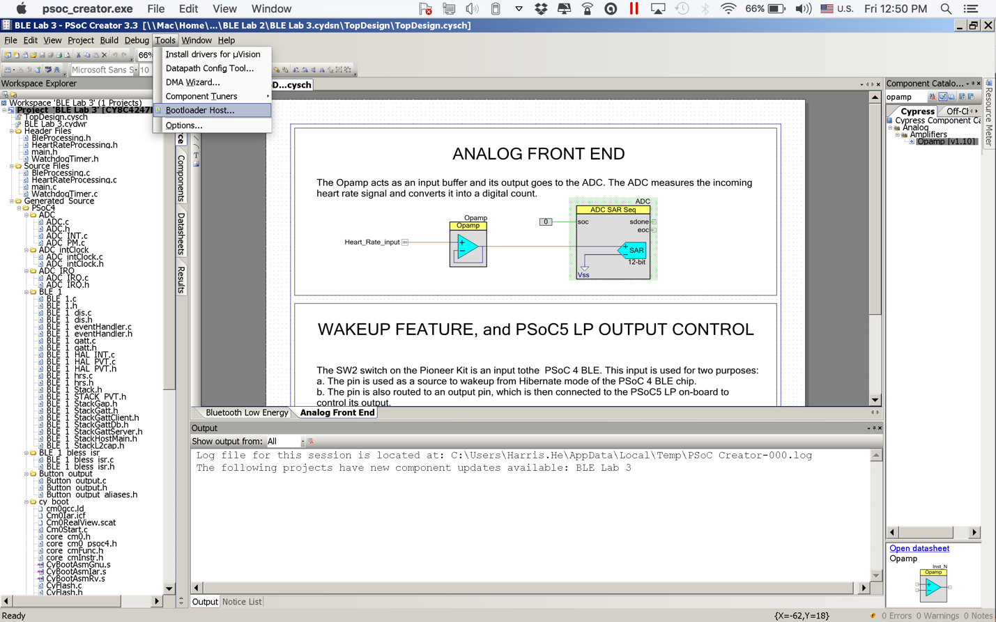

1. Click on the OpAmp to configure it as follows:

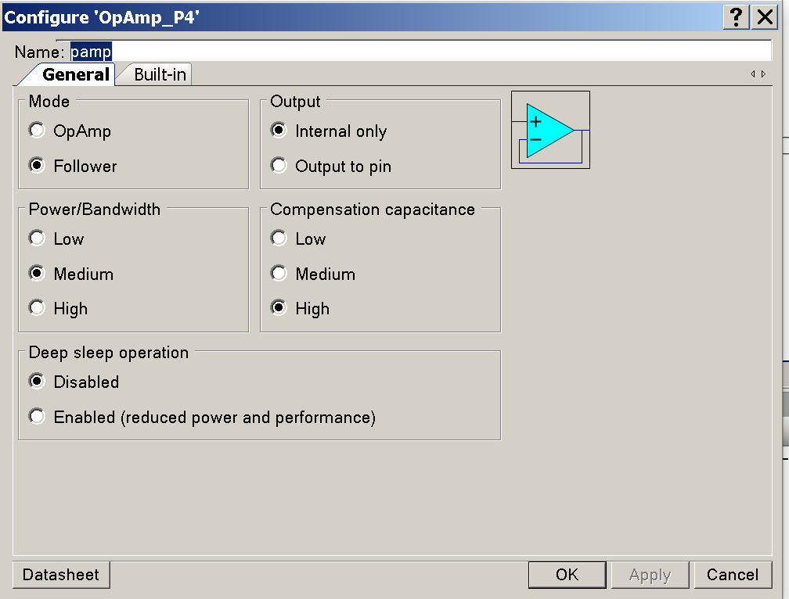

1. Click on the ADC, and then on General tab to configure it as follows:

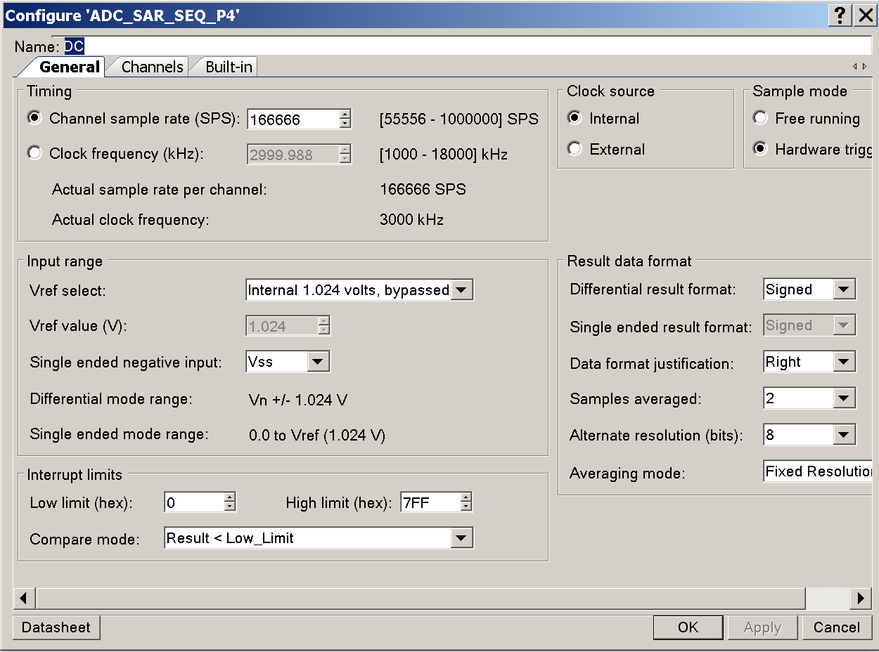

1. Click on the channels tab, and then insert the following configurations

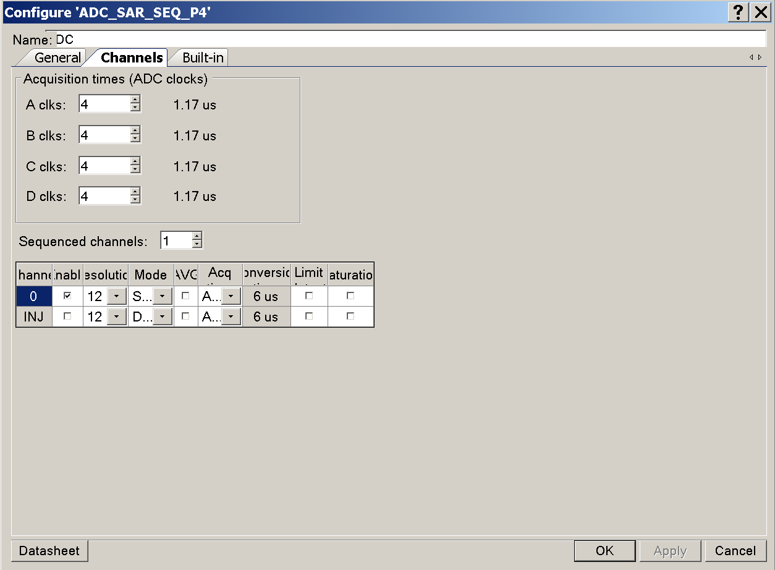

1. Add the connections, and your project will appear as follows:

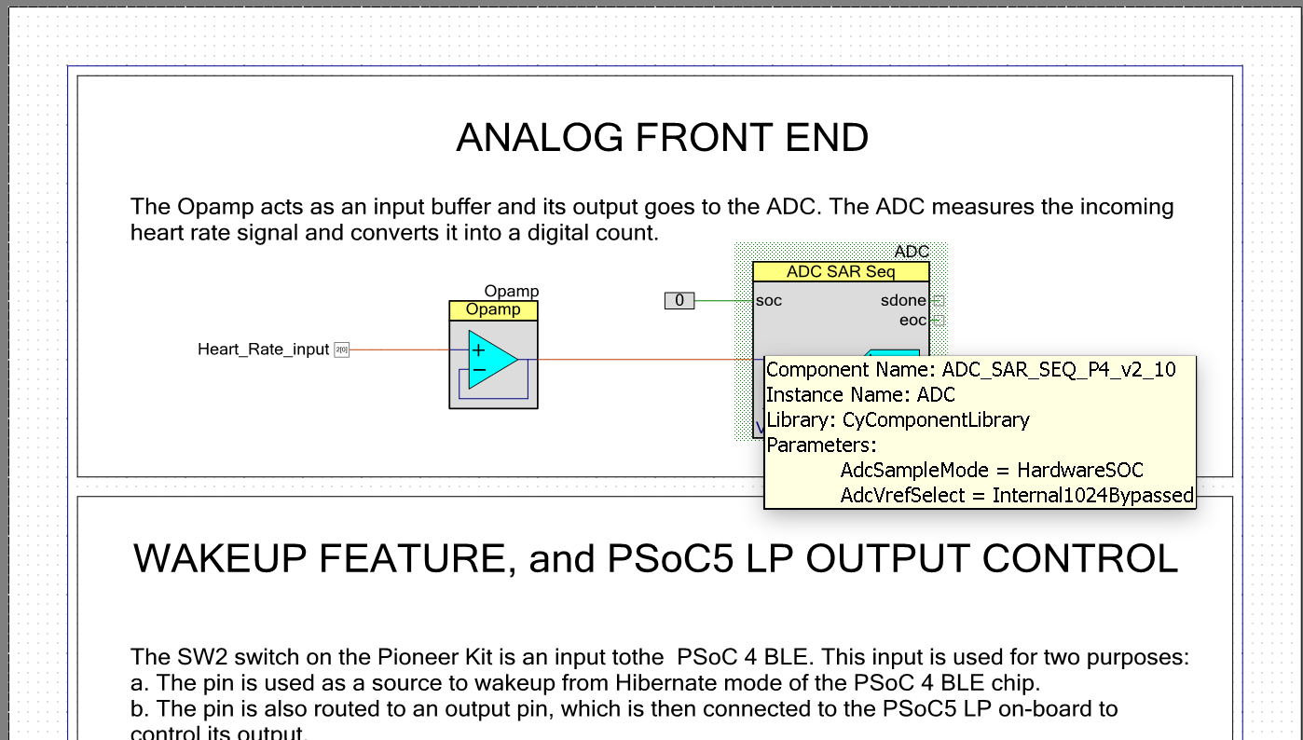

1. Click on Build the select Build BLE Lab 2 to compile the C code, make sure there are no errors after compiling the code.
2. Remove the USB connector.
3. While pressing the SW1 (Reset) switch, plug in the kit’s USB connector to the PC. This puts the kit into the bootloader mode.

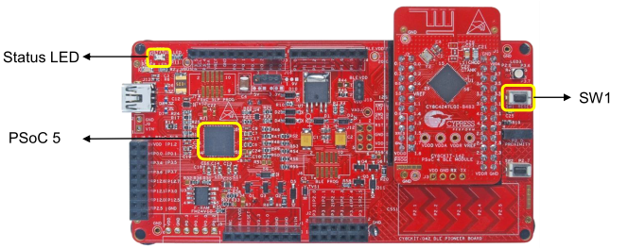 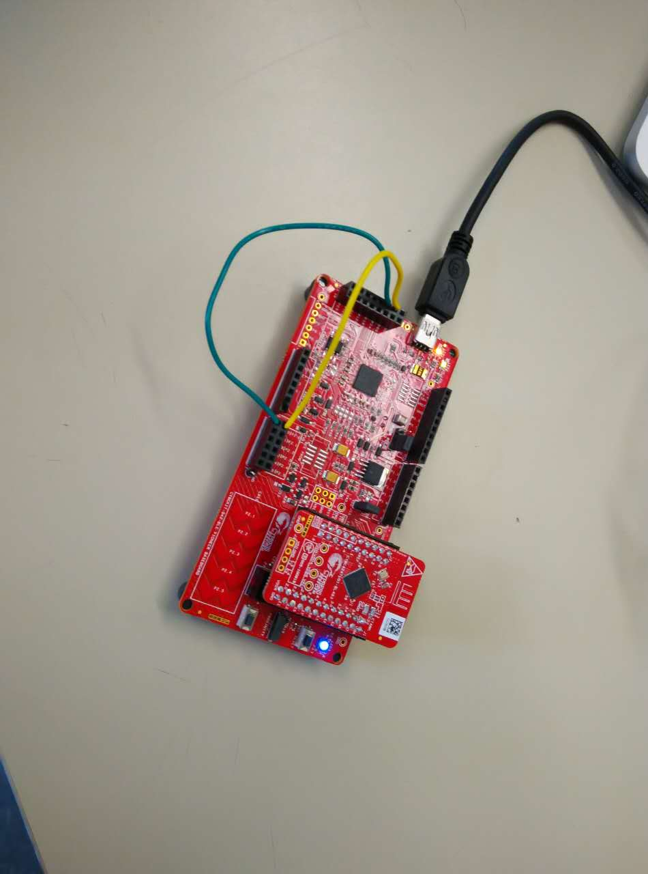

1. Launch the bootloader host as in the graph

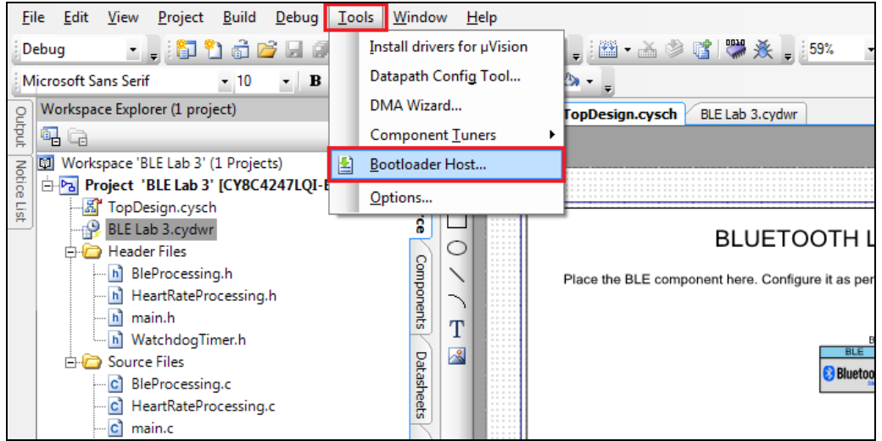

1. Configure the filters as in the following graph:

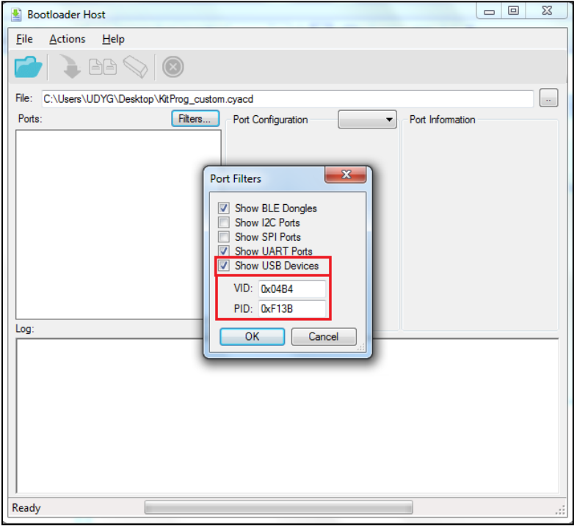

1. Select the USB human interface as follows:

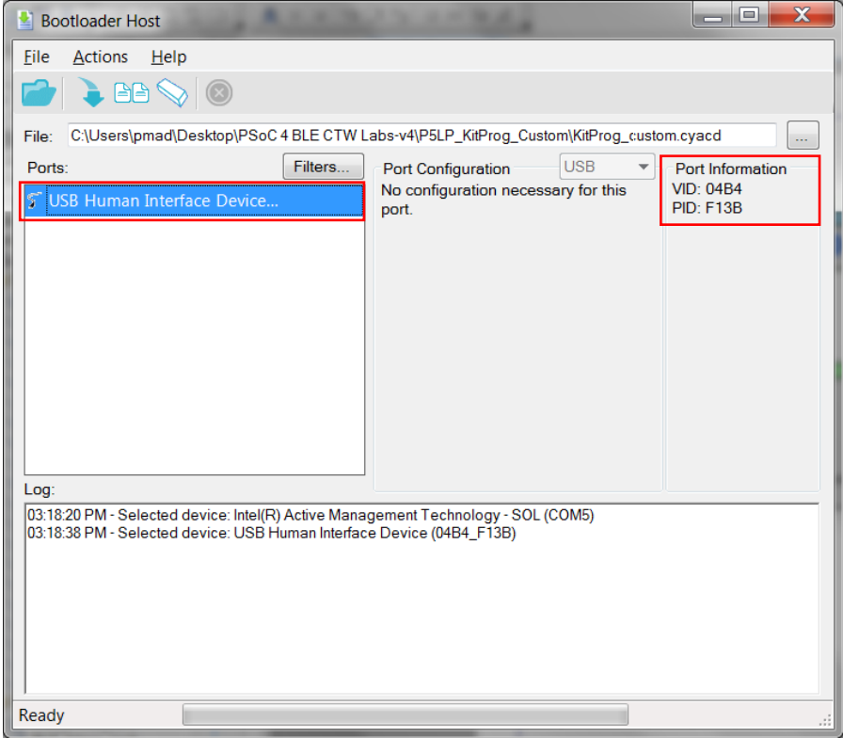

1. In the Bootloader Host Tool, Open the bootloadable (*.cyacd) file, available in the BLE_Labs -> P5LP_KitProg_Custom folder. You can do this by selecting the File > Open… menu item and then selecting the provided KitProg_custom.cyacd file.
2. . Program the PSoC 5 on the kit. You can do this by selecting the Actions > Program menu item.
3. Connect jumpers as in below graph:

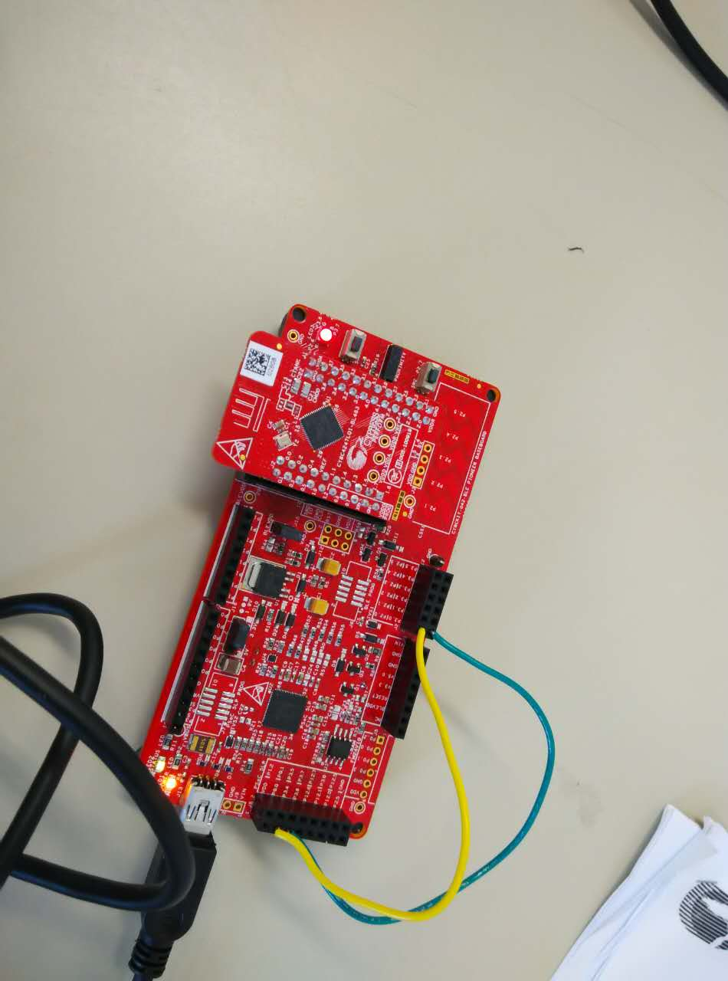

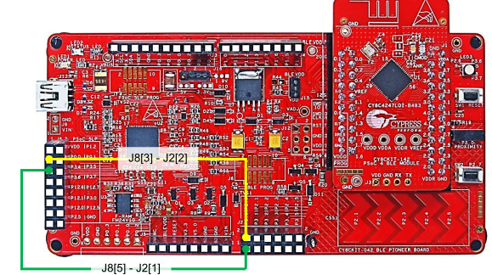

1. The RGB LED will be green, to indicate ready to connect.

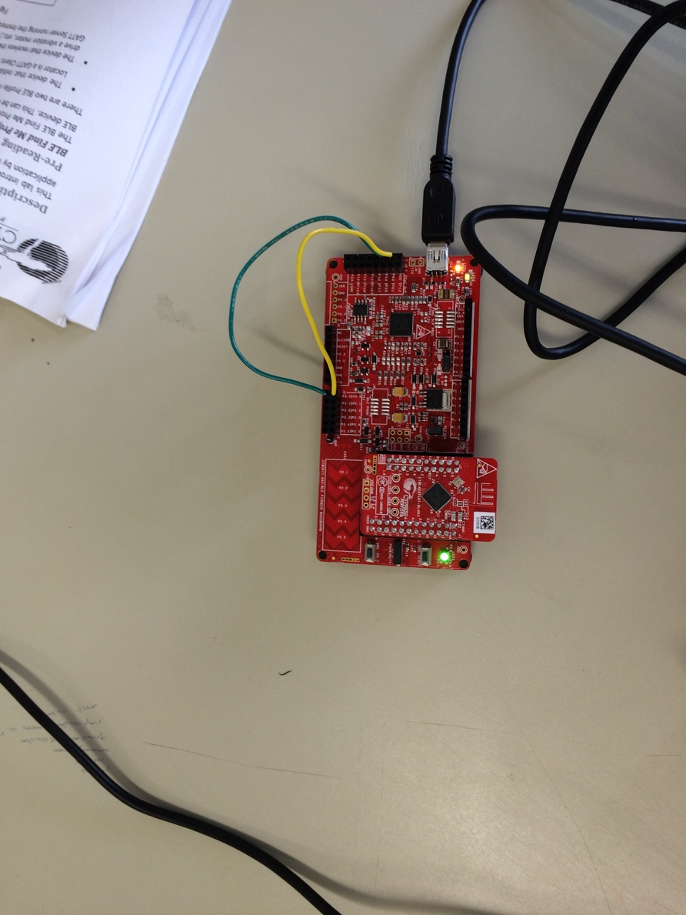

1. First, we will test the lab using CYSMART Test & Debug Tool. Select the USB dongle as follows:

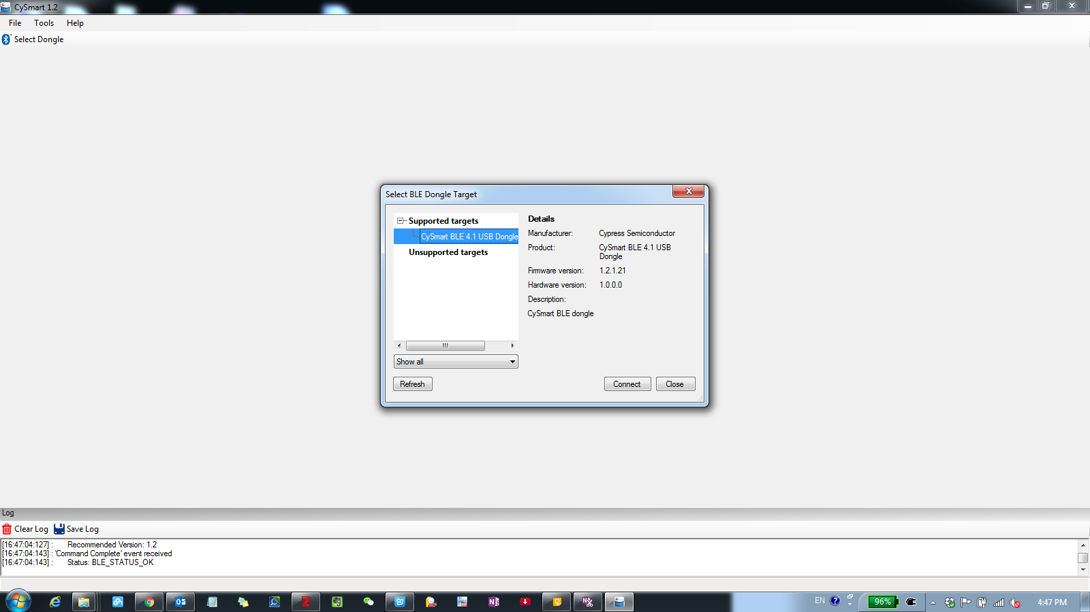

1. Start scan to detect the device and then connect:

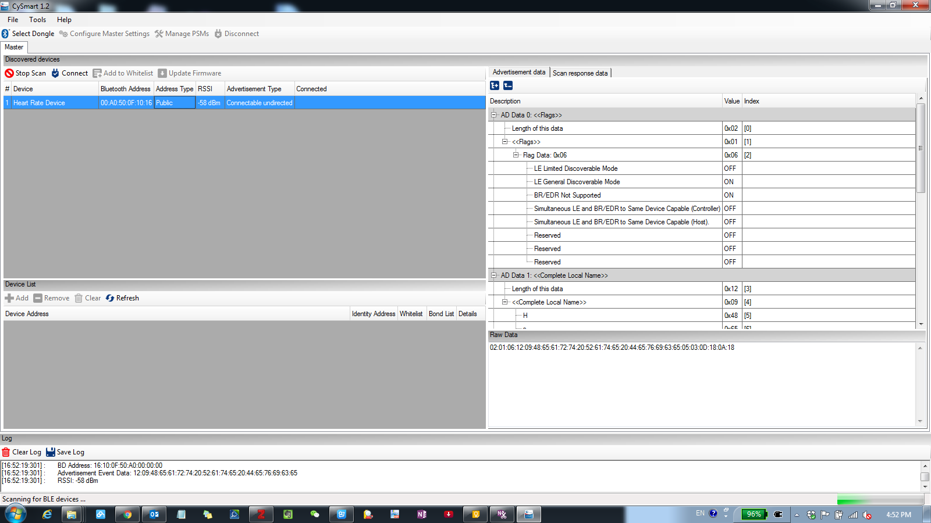

1. Click on discover all attributes as follows:

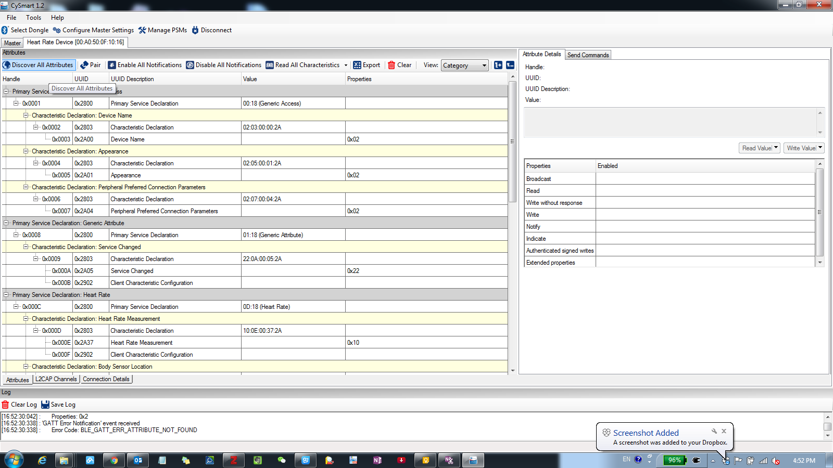

1. Click on enable all notifications

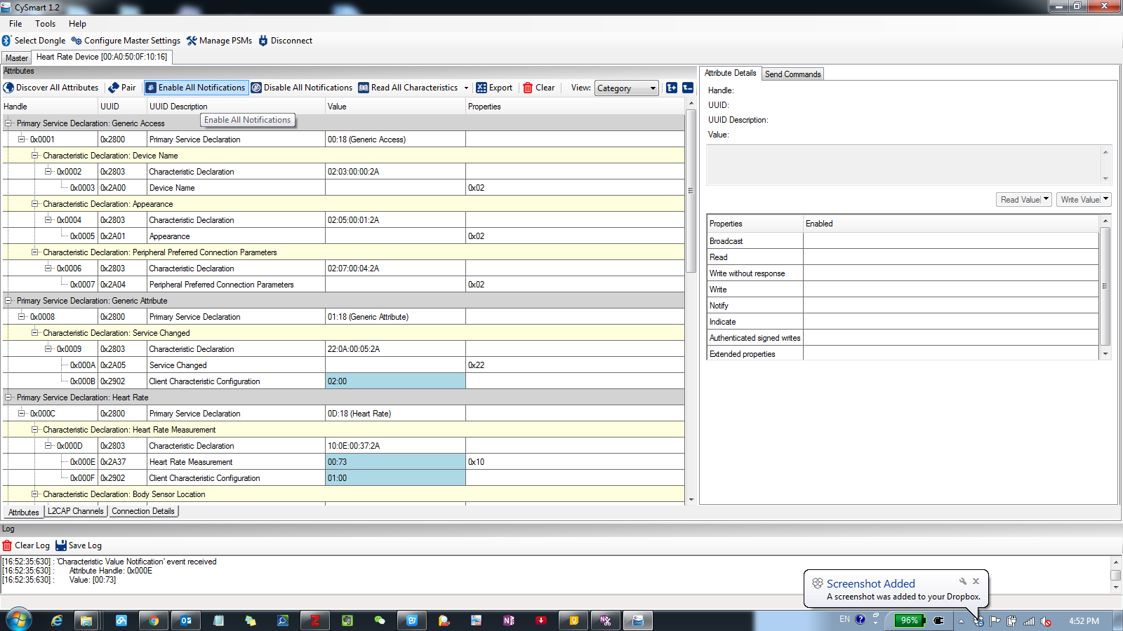

1. Observe the heart rate in hexadecimal. Update is every second.

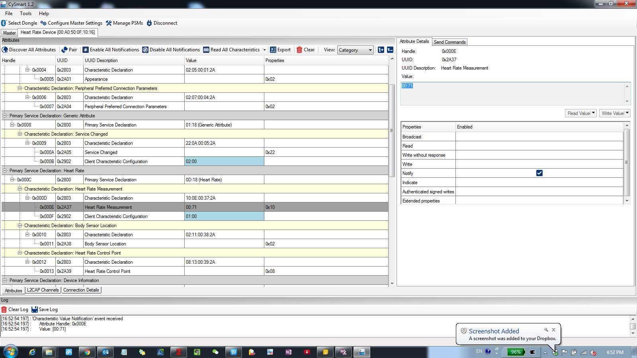

1. To test the configuration on IPhone, install CySmart App on the phone.
2. Choose the heart rate service as follows:

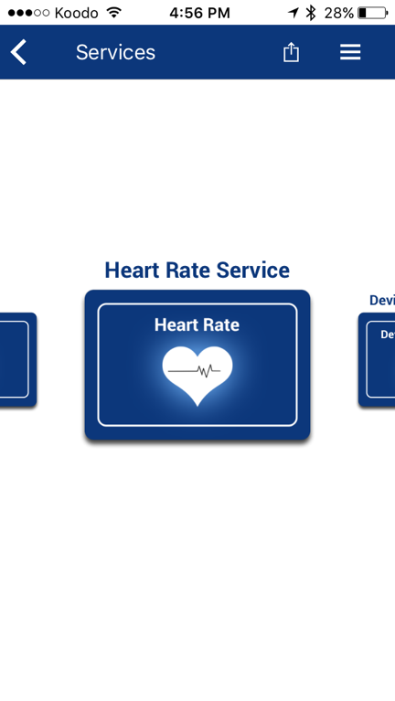

1. Select Heart Rate Service:

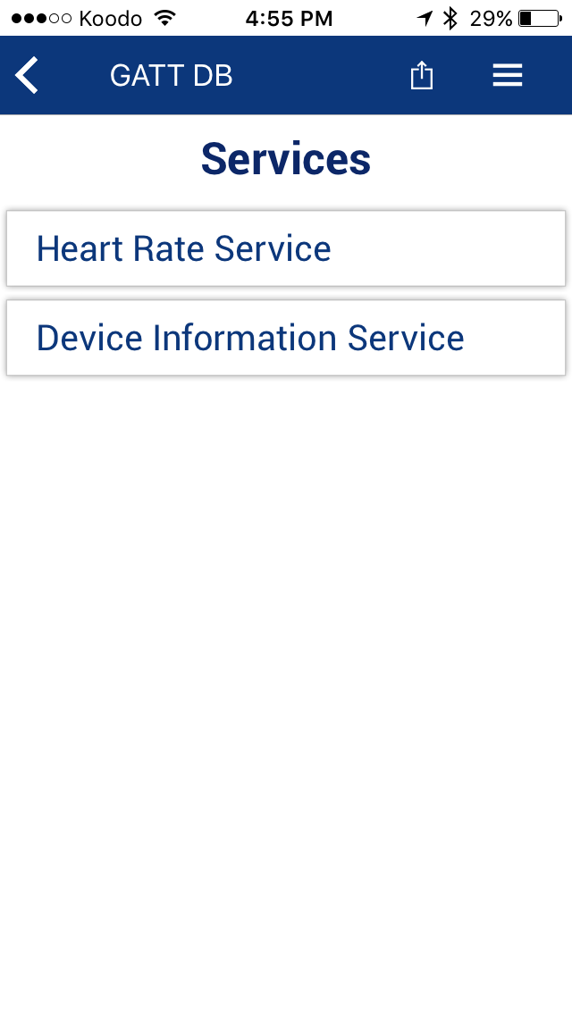

1. Select Notify Heart Rate Measurement:

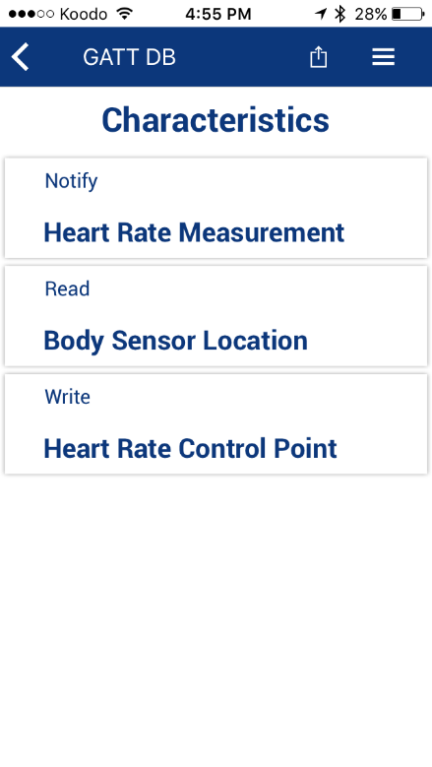

1. Observe Heart Rate Measurement

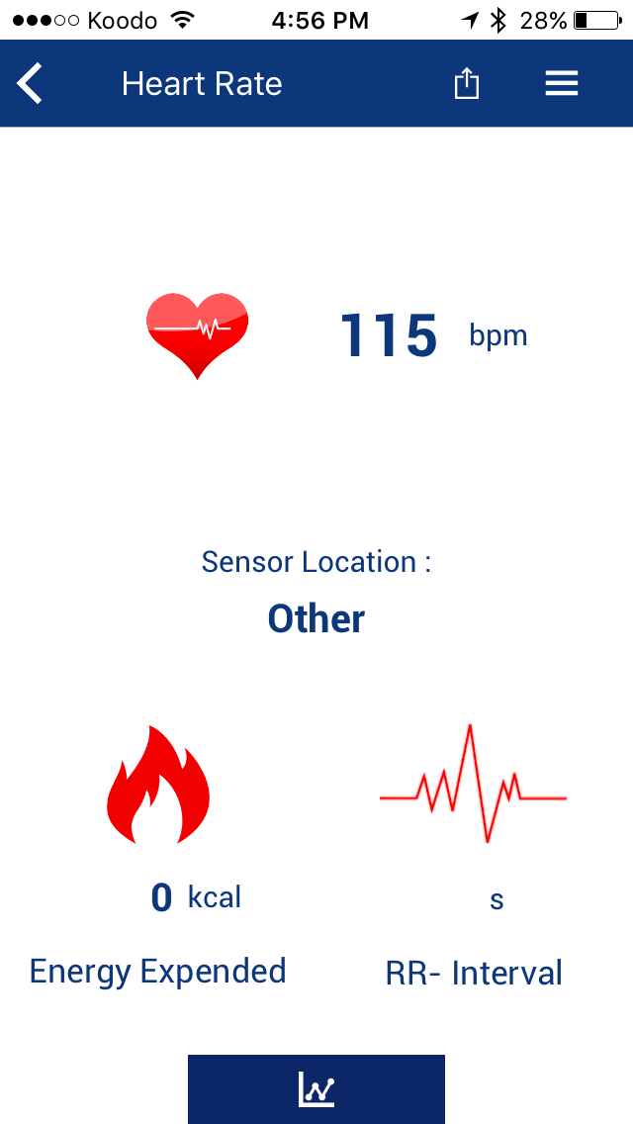

1. To restore the default firmware on the PSOC 5, we open CYSmart programmer, and then click on utilities as follows:

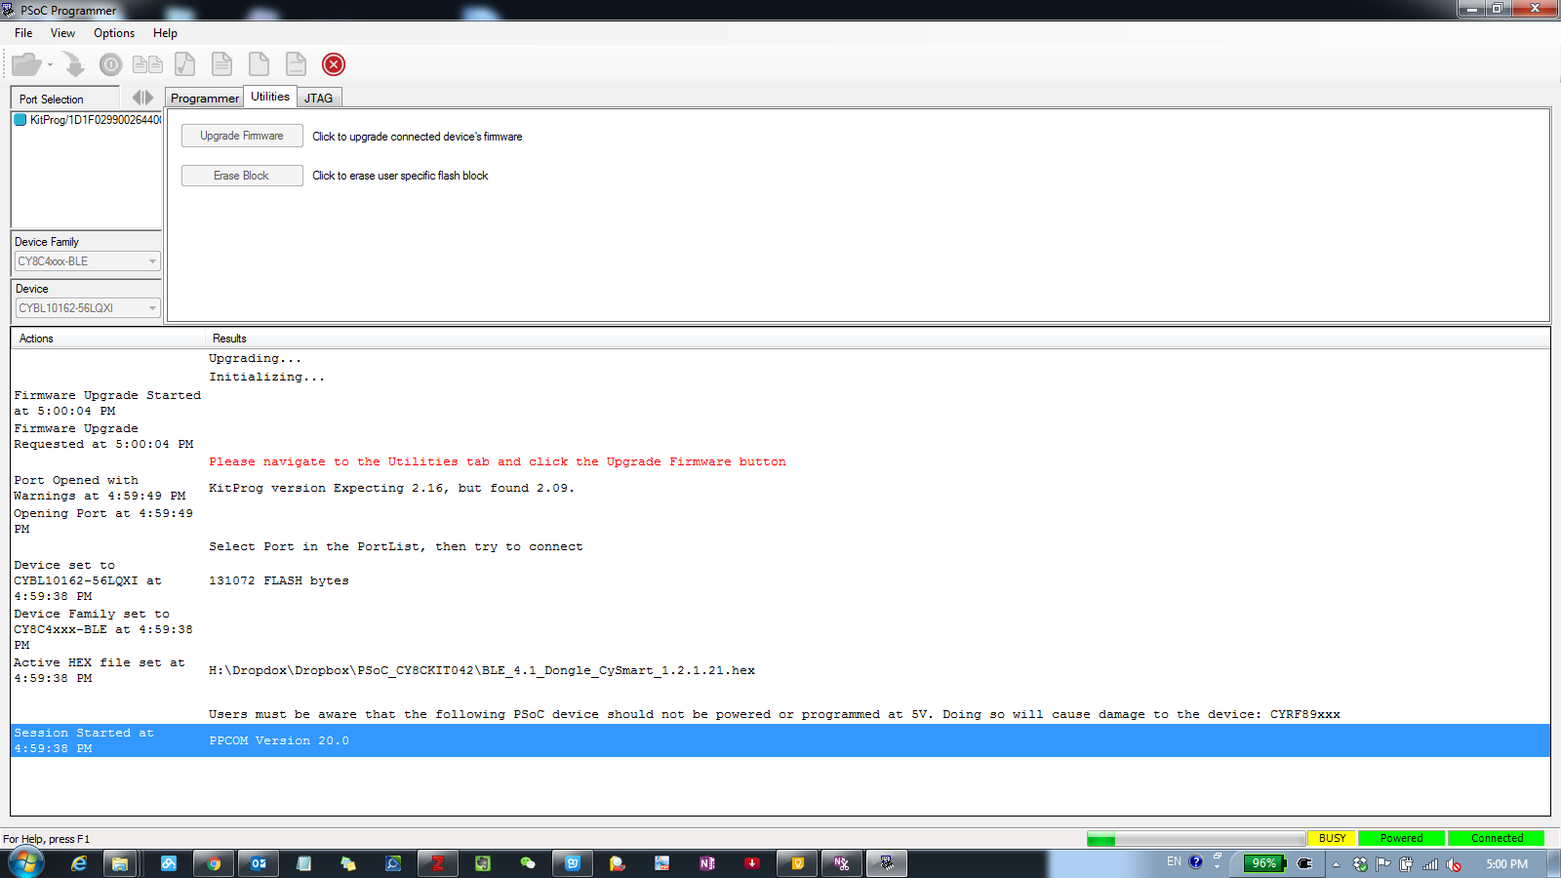

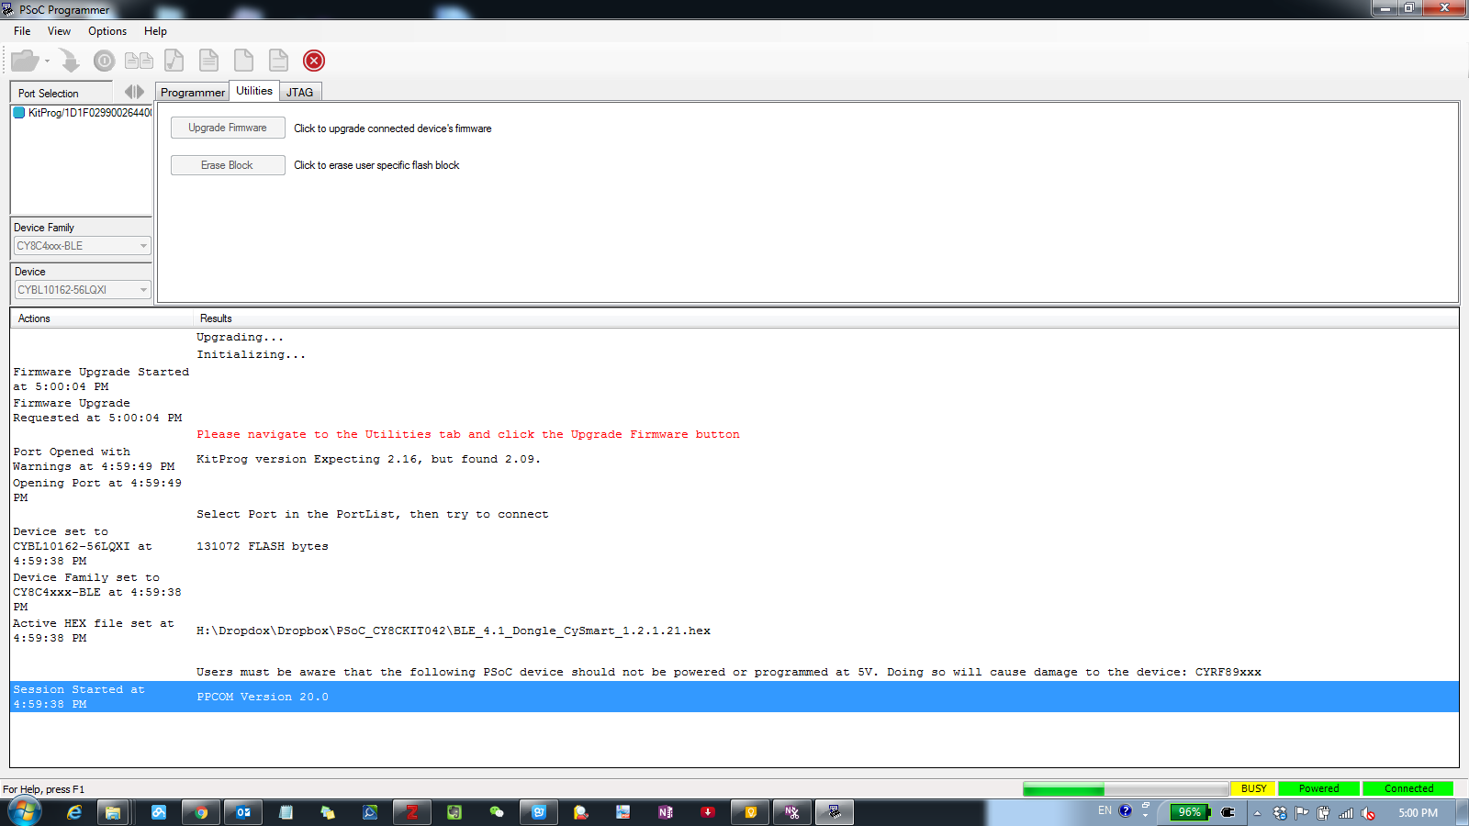

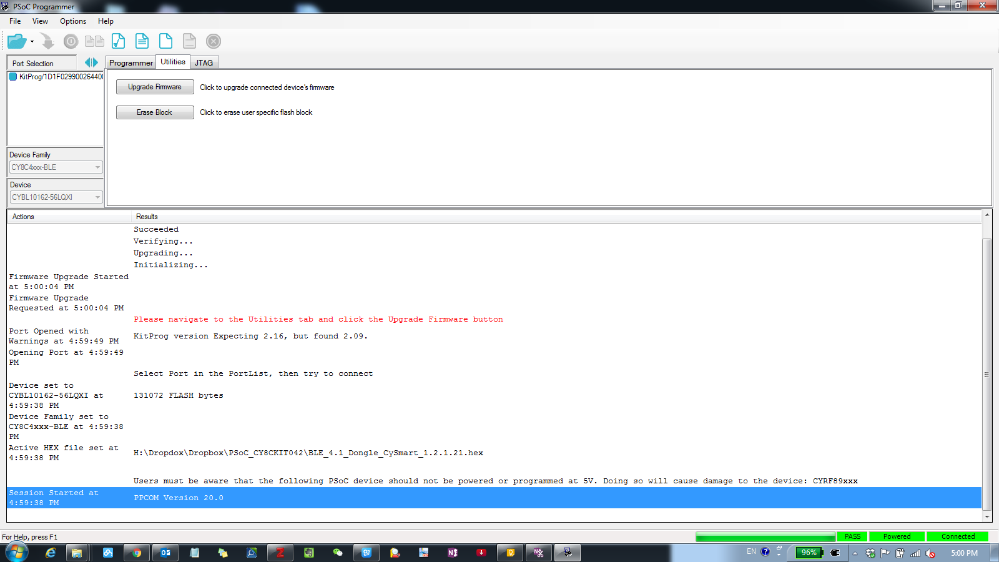

# **3.Conclusion:**

The BLE Kit acted as the Heart Rate Sensor. Though PSoC 5 firmware updated, the microchip generate simulation Heart Rate. Then through the wire line connection, BLE calculate Heart Rate and sent the information to CYSMART tool, after the connection was established. The Heart Rate Collector showed the heart rate in Hexadecimal, while the IPhone App showed the heart rate in decimal.

This lab give us a good opportunities to implement BLE IoT function. Using it Heart Rate profile, we can set up Heart Rate function very quickly and easily. It is also can been seen that the Opamp Component is ‘soft’. The analog circuit can be configuration by software and “system on chip” framework. The whole lab give us a deep mind on how IoT system work.